Department of Computer Science and Engineering

BRAC University

CSE 260: Digital Logic Design

Experiment # 2

Applications of Boolean algebra

Objective:

- To investigate the rules of Boolean algebra.
- To gain experience working with practical circuits
- To simplify a complex function using Boolean algebra

Required Components and Equipments

- AT-700 Portable Analog/Digital Laboratory
- 7400×1
Diagram of Circuit:
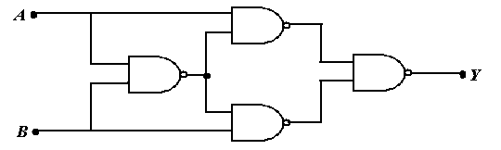
Procedure:

- Construct the Circuit of Figure 1, on the breadboard of AT-700.
- Remember each IC’s pin 14 connected to “+5V” position of DC Power Supply of AT-700, and pin 7 connected to “GND” position.
- Connect the inputs to Data switches and outputs to any position of LED Display.
- Find out the outputs for all possible combinations of input states.
- Write down the input-output in tabular form.

Report:
The report should cover the followings

- Name of the Experiment
- Objective
- Required Components and Equipments
- Experimental Setup (You must draw the IC configurations)
- Results (Truth Table) and Discussions .The discussions part must include the answers of the following questions:
  - What is the Boolean Equation for the output?
  - Simplify the Boolean equation.
  - The circuit’s function is identical to a single gate. Write down the name of that gate.
BOOLEAN THEOREMS

- x.0=0
- x.1=x
- x.x=x
- 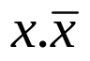=0
- x+0=x
- x+1=1
- x+x=x
- 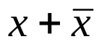=1
- x+y=y+x (Commutative laws)
- x.y=y.x (Commutative laws)
- x+(y+z)=(x+y)+z=x+y+z (Associative laws)
- x(yz)=(xy)z=xyx (Associative laws)
- (w+x)(y+z)=wy+xy+wz+xz
- x+xy=x
- 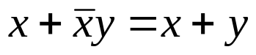
- 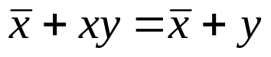
- 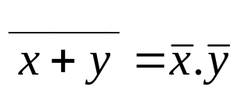 (DeMorgan’s Theorem)
- 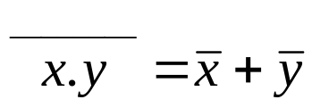 (DeMorgan’s Theorem)

